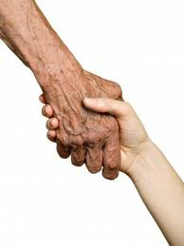
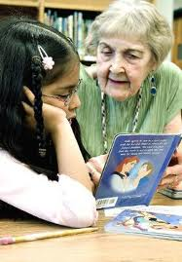
The Senior Volunteer Program has been developed by Code-X International, to address the many issues associated with our growing populations of older and retired persons.
This program is designed to encourage active aging through volunteer projects that will keep senior citizens happy, healthy and empowering. This is accomplished through the development of specialized volunteer programs, which are suited to the specific needs and interest of our older population.

The Grandparent Project is the pilot project of our Senior Volunteer Program. The project pairs older and retired persons, 50+, with immigrant and economically deprived children to practice the Dutch language, through storytelling and games.
This Program will provide excluded children with stronger integration into the Dutch community. And our senior volunteer will be able to contribute to their local community while helping the strain on public services and integration courses.

Oudezijds Voorburgwal 314
1012GL Amsterdam, NL
www.codex-international.org
info@code-x.nl
Code-X International

The Senior Volunteer Program

The Grandparent Project
The Senior Volunteer Program
Presented By:
Code-X International

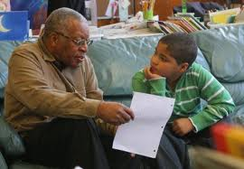
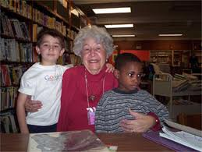

Senior Corps, a USA based nationwide volunteer program for people 55+ years old, has shown the civic value of older and retired persons.
According to the Corporation for National and Community Service, the program has facilitated “18.7 million older adults – contributed on average more than 3 billion hours of service in their communities per year between 2008 and 2010. The yearly economic benefit of this service to the nation equals more than $64 billion.”

In a time of world-wide economic crisis, when social programs and services are being reduced, or scrapped altogether, the Senior Volunteer Program will prove to be economically beneficial to local and national government.
Our projects will focus on areas in the local community where social services and funds have been stretched to their max. Projects are designed to take pressure off of social programs allowing our senior volunteers to not only contribute to their local community, but also to their national economic interest.

The Economic and Social Impact of Senior Volunteering is Limitless…

2012 Year of

Active Aging and Intergenerational Solidarity
In accordance with the aims and goals of the 2012 Year of Active Aging and Intergenerational Solidarity, Code-X is implementing the Senior Volunteer Program.
Through the Senior Volunteer Program, Code-X International will work to change the nature of aging and the expectations of retirement. By encouraging older and retired persons to volunteer their skills and time towards local community projects we will be able to encourage them to stay more active and therefore more social and physically healthier.

